EX NO: 9 | Website IP Identification and DNS Response Time Analysis using Wireshark
DATE:18/08/26

Objectives
- To capture and analyze DNS query and response packets using Wireshark and identify the IPv4 (A Record) and IPv6 (AAAA Record) addresses of websites.
- To measure and evaluate the DNS response time for selected websites and verify the obtained IP addresses using the nslookup command.

Tools Required
  - Wireshark
  - Command Prompt (Windows) / Terminal (Linux)
  - Web Browser (Google Chrome / Mozilla Firefox)
  - Internet Connection
  - Websites:
    - arms.sse.saveetha.com
    - www.gmail.com
    - www.yahoo.com
Theory
The Domain Name System (DNS) translates human-readable domain names into IP addresses. DNS records include:
  - A Record – Maps a domain name to an IPv4 address.
  - AAAA Record – Maps a domain name to an IPv6 address.
DNS response time is the time taken by a DNS server to respond to a query. Wireshark can capture DNS packets and measure the response time between DNS request and response packets. Procedure
Part A: Capturing DNS Traffic Using Wireshark
- Launch Wireshark.
- Select the active network interface (Wi-Fi/Ethernet).
- Start packet capture.

dns
- Apply the display filter:

- Open a web browser and access:
  - arms.sse.saveetha.com
  - www.gmail.com
  - www.yahoo.com
- Observe the DNS query and DNS response packets.
- Expand the DNS response packet and note:
  - IPv4 address (A Record)
  - IPv6 address (AAAA Record)

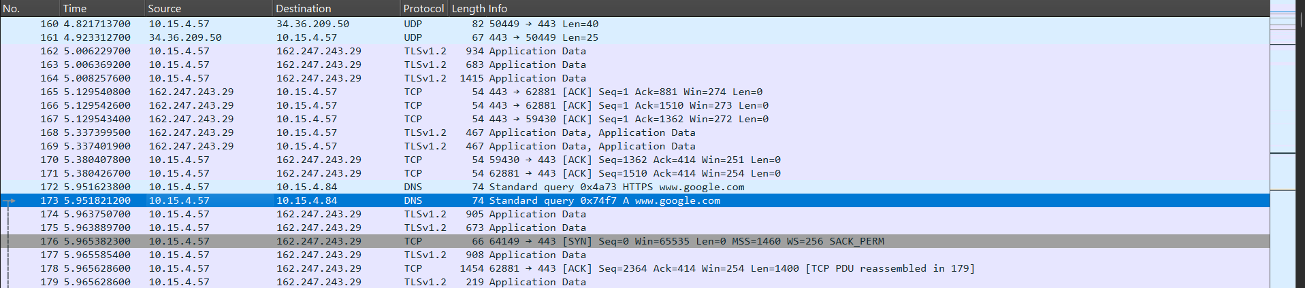
Part B: Measuring DNS Response Time
- Identify a DNS query packet.
- Find the corresponding DNS response packet.
- Note the timestamps of both packets.
- Calculate:
DNS Response Time = Response Timestamp − Query Timestamp
- Record the response time for each website. Part C: Verification Using nslookup
- Open Command Prompt.
- Execute:
- nslookup arms.sse.saveetha.com
- nslookup www.gmail.com nslookup www.yahoo.com
- For IPv6 verification:
- nslookup -type=AAAA arms.sse.saveetha.com
- nslookup -type=AAAA www.gmail.com nslookup -type=AAAA www.yahoo.com
- Compare the IP addresses obtained from nslookup with those observed in Wireshark.

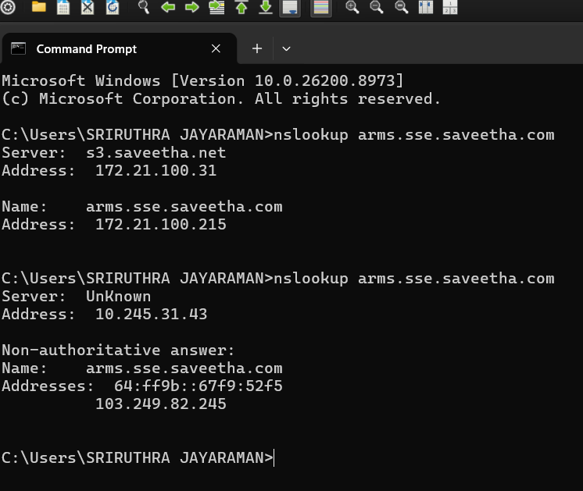

Output

Website | IPv4 Address | IPv6 Address | DNS Response Time (ms)
arms.sse.saveetha.com | 10.15.4.57 | fe80::bcf6:75ff:fe62:a6b3 | 2.6 ms
www.gmail.com | 10.15.4.84 | bcf6::75ff: fe80:a4v6 | 1.07 ms
www.yahoo.com | 10.15.4.59 | fe80::bcf6:75ff:fe62:a6b3 | 23.98 ms

Results Objective 1:
DNS query and response packets were successfully captured and analyzed using Wireshark. The IPv4 (A) records and IPv6 (AAAA) records of the selected websites were identified from the DNS response packets.

Objective 2:
The DNS response time for the selected websites was measured from the captured DNS packets and the obtained IPv4/IPv6 addresses were successfully verified using the nslookup command. The results confirmed the accuracy of the DNS resolution.

Test Case Question 1
Implement the specified setup and identify the IPv4 (A Record) and IPv6 (AAAA Record) addresses of selected websites using DNS packets captured with Wireshark.

Case 1
- Number of PCs: 1
- Internet Connection: Available
- Packet Analyzer: Wireshark
- DNS Protocol: DNS
- Websites: arms.sse.saveetha.com, www.gmail.com, www.yahoo.com Tasks
- Capture DNS query and response packets using Wireshark while accessing the selected websites.
- Identify and record the IPv4 (A Record) and IPv6 (AAAA Record) addresses from the DNS response packets.
- Verify the obtained IP addresses using the nslookup command and compare the results with those captured in Wireshark.

Test Case Question 2
Implement the specified setup and measure the DNS response time and verify the IP addresses of selected websites using Wireshark and nslookup.

Case 2
  - Number of PCs: 1
  - Internet Connection: Available
  - Packet Analyzer: Wireshark
  - DNS Protocol: DNS
  - Websites: www.amazon.com, www.microsoft.com, www.wikipedia.org

Tasks
- Capture DNS query and response packets for the selected websites using Wireshark.
- Determine the DNS response time by measuring the time difference between the DNS query and corresponding response packets.

- Verify the IPv4 (A Record) and IPv6 (AAAA Record) addresses using nslookup and compare the DNS response time and resolved addresses for the selected websites.

